**Scenario: The bike enthusiast**

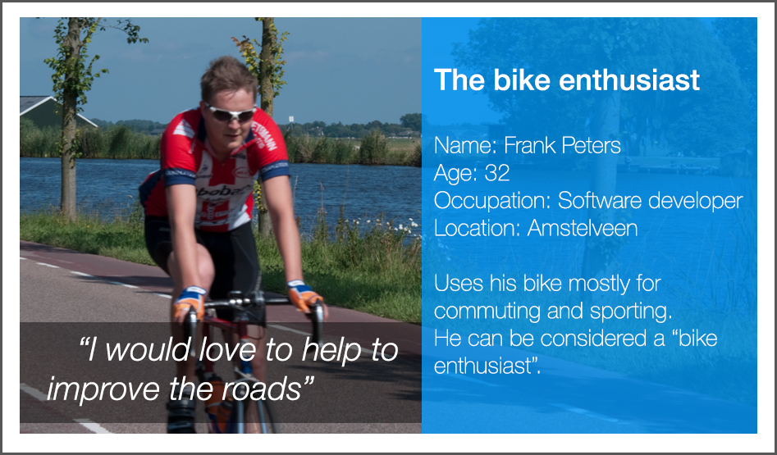

The weather is nice outside; Frank decides to go out for a ride.

He slides his smartphone in the holder that is attached to his steer. He opens the RWS app and presses “Start”. The app starts to record the GPS and accelerometer data.

While cycling through nice scenery, Frank sees a big gap in the road. He thinks that this could be a potentially hazardous situation. He presses the “take photo” button to directly take a shot of the gap, and decides to share the photo with the RWS. The photo includes GPS data, so the road maintenance department can directly judge if they should repair it.

He decides to go on and when he arrives at home he presses the “Stop” button, to stop the recording. When he is connected to Wi-Fi, the app asks to upload his data.

When he opens the RWS web-interface on his PC, the recorded journey is shown on a map. There is an overlay with indications of bad stretches of road surface, which are based on the accelerometer data. If an indication is right, he can click on a tick box to verify. When he is finished he can share this information with RWS.

**Scenario: The commuter**

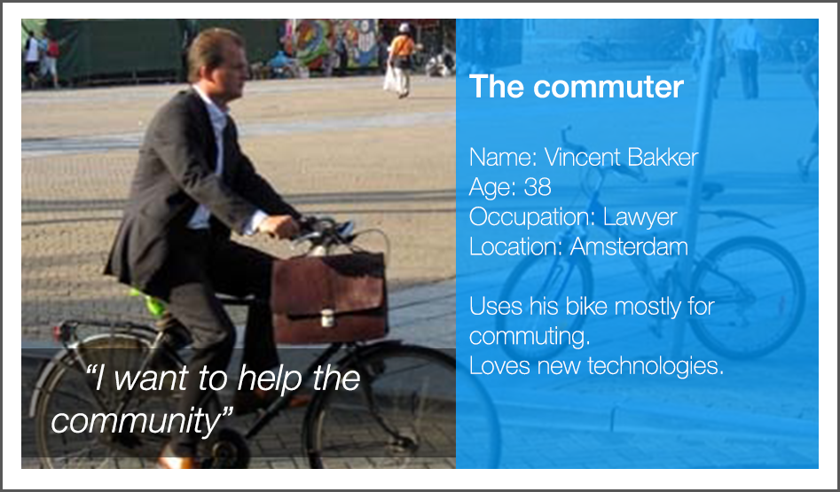

Vincent commutes every day to his work. Since he lives just outside the city it takes him 20 minutes to travel to his work. He really likes the idea that he can personally help improving the roads and bike lanes he is using everyday.  
When leaving his house he slides his smartphone in the holder and opens the app. He presses the “Start” button to start recording.

When he arrives at work he presses the “Stop” button. When he enters the building his smartphone automatically connects to the Wi-Fi and the app asks to upload the data, which he allows. Vincent doesn’t have any time to verify the potential bad stretches of road. Nonetheless the information is useful.

**Scenario: OV-fiets**

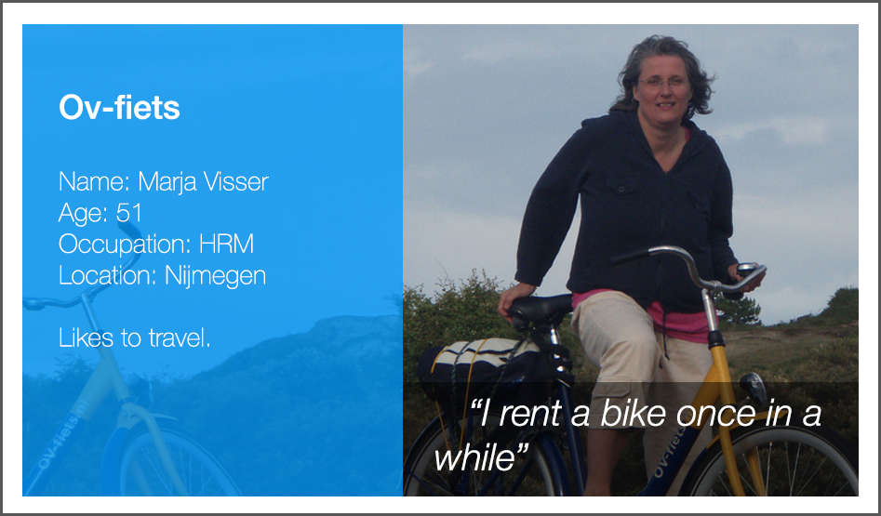

Marja decides to go to Zandvoort for a day. When she arrives she rents an OV-fiets at the train station.

The OV-fiets contains a recording device with GPS and an accelerometer.   
The device notices it when Marja’s rented bike leaves the bicycle storage and starts recording automatically. While cycling around Zandvoort she stops once in a while for a break. The device detects this and pauses the recording. It starts again when the bicycle is used.  
When Marja returns her bike at an OV-fiets location the device stops recording and uploads the data automatically.